Run the APK file in desktop emulator

* Prerequisites

1. Download and install the Bluestacks

Get it from the URL “http://www.bluestacks.com/”

1. Download the APK file

* AWS server
* Prerequisites done.
* Navigate to the APK file it`s in the “E:\Abeo-Projects\TnN\APK”
* Right click and select the first option “Open with Bluestacks App installer”



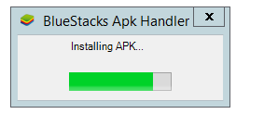

* Hold for some time once the installing is finished, search for Bluestacks in windows

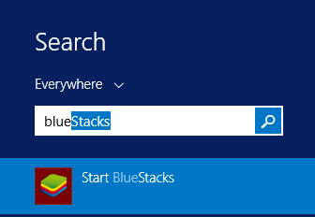

* Open the BlueStacks and click the back icon highlighted in white circle

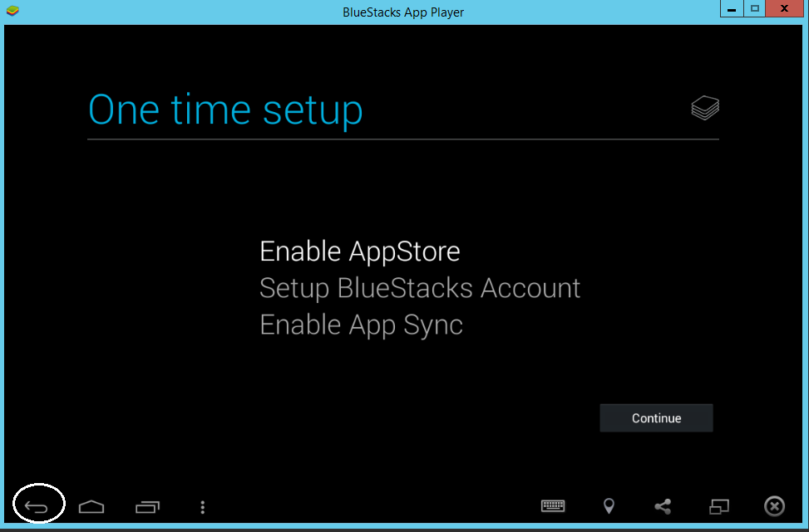

* You find the TnN app in the startup screen

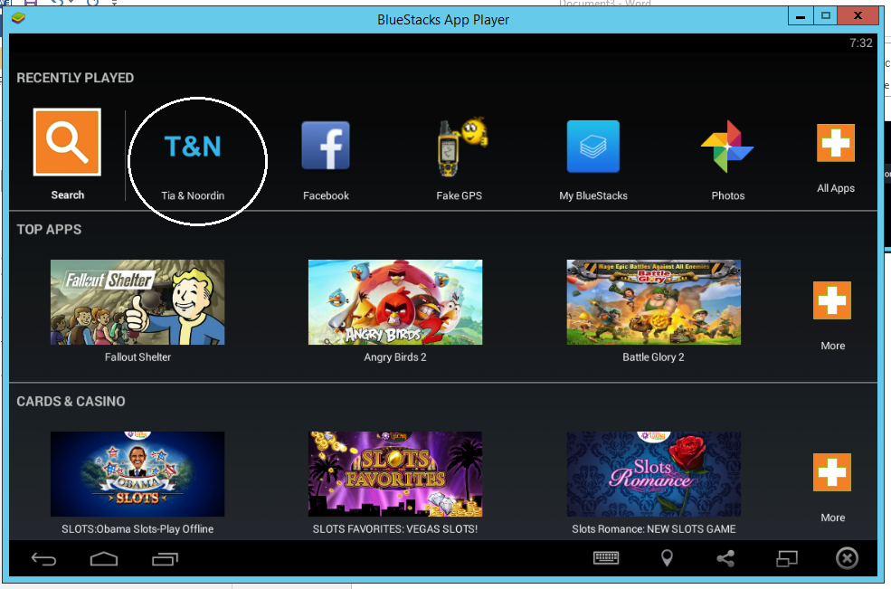

* Local System
* Same process steps before that done the prerequisites.